Auston Gray

MAE 251, Aerospace Vehicle Performance

Dr. Gopalarathnam

November 21, 2017

Project 2: Drag Estimation of Aircraft

Used Data pertaining to Beechcraft Bonanza A36

1. **Dimensions of Airplane used in Calculations**:

Wing Area S = 181.0 ft^2 (0.3048m/1ft)^2 = 16.815 m^2

Wing Span b = 33.5 ft (0.3048m/ft) = 10.211 m

Aspect Ratio AR = (b^2)/S = ((10.211 m)^2)/(16.815 m^2) = 6.2007

Estimations and Approximations using Ruler and Proportional Dimensions:

Using actual on-paper measurement of wingspan to determine measured dimensions

Approximated Part of Wing in Fuselage as a Rectangle

Approximate Scaled Width of Fuselage along Wing = 0.0135m on paper

Width of fuselage along wing = 0.0135m (10.211m/0.1175m) = 1.1732m

Measured scaled length of fuselage along wing = 0.025m

Length of fuselage along wing = 0.025m (10.211m/0.1175m) = 2.1726m

Estimation of Horizontal Tail Area:

Span of Horizontal Tail = 12.162 ft (0.3048m/ft) = 3.7084m

Scaled root chord of horizontal tail = 0.011m

Scaled tip chord of horizontal tail = 0.009m

Calculating Area of Horizontal Tail:

Assumed length of fuselage along horizontal tail = horizontal tail root chord

Width of scaled fuselage at front of horizontal tail (maximum along tail) = 0.005m

Horizontal Tail Root Chord = 0.011m (10.211m/0.1175m) = 0.95592 m

Tip Chord of Horizontal Tail = 0.009m (10.211m/0.1175m) = 0.78212 m

Maximum width of fuselage along horizontal tail = 0.005m (10.211m/0.1175m) = 0.43451 m

Measured dimensions of Vertical Tail:

Approximated as slanted trapezoid

Height of tail = 0.016m (10.211m/0.1175m) = 1.3904 m

Length of tip: 0.008m (10.211m/0.1175m) = 0.69522 m

Length of Tail Base = 0.0115 m (10.211m/0.1175m) = 0.99937 m

Dimensions to Estimate the Frontal Area of the fuselage:

Approximated Frontal Area of fuselage as a Rectangle with a Semicircle on top of it

Width of fuselage = 0.0135 m (10.211m/0.1175m) = 1.1732 m

Height of Bottom Rectangle = 0.01025 m (10.211m/0.1175m) = 0.89075 m

Radius of Semicircle on top = 0.00675 m (10.211m/0.1175m) = 0.58659 m

1. **Estimating airplane coefficient of lift at angles of attack ranging from 0 degrees to 10 degrees:**

Assumed airplane lift coefficient is same as wing coefficient of lift

Determining value of a (dCL/d $α)$ for wing:

Assumed a0 = 0.11/degree

$$a=a_{0}\left(\frac{AR}{AR+2}\right)=0.11/\deg\left(\frac{6.2007}{6.2007+2}\right)=0.083173$$

From NACA 4415 airfoil diagram at Re = 3 million, the Zero Lift angle of Attack is -4 degrees.

$$C_{L}=a\left(α-α_{0L}\right)=0.083173(α-\left(-4\right))=0.083173(α+4)$$

Used excel to calculate wing lift coefficients for angles of attack from 0 degrees to 10 degrees in 1 degree increments

1. **Estimation of Induced Drag of Airplane**:

Assumed C_D,i of airplane is equal to C_D,i of wing

$$C_{D,i}=\frac{C_{L}^{2}}{πARe_{w}}$$

Calculated Induced drag of airplane at each angle of attack with previously calculated values in Excel spreadsheet (see Table in problem 6)

1. **Drag Calculations for each Angle of Attack**:
2. Estimating value of CDP,wing using Exposed Wing Area and Listing Values of Product of CDP,wing and Swing,exposed:

From Airfoil Data for NACA 4415, Drag Coefficient of Wing with Calculated Lift Coefficients recorded in Excel spreadsheet

Determining Exposed Area of Wing:

Exposed Area of Wing = Total Wing Area – Area of wing covered by fuselage = Wing Area S – (Length of fuselage along wing)(Width of fuselage along wing) = 16.815 m^2 – (1.1732m)(2.1726m) = 14.266 m^2

CDP,wing values multiplied by Exposed Area of Wing in Excel to Determine Product of drag area of wing (see Table in problem 4, part i)

1. Calculating CDP of Horizontal Tail

Using the NACA 0012 airfoil data with Re = 3 million and a constant lift coefficient of 0.5, the drag coefficient is 0.0074.

Calculating exposed area of given horizontal tail:

Area of horizontal tail = Area of two trapezoids – Area covered by Fuselage

= 2(1/2)*(Span)*(Root chord + tip chord) – (1/2)*(Root chord)*(Width of fuselage at Tail)

=2(1/2)*(3.7084m)*(0.95992m + 0.78212 m) – (1/2)*(0.95592m)*(0.43451m) = 6.2516 m^2

Product of SHT and CDP,HT = (6.2516 m^2)(0.0074) = 0.046262

1. Estimating CDP,VT and listing product of Vertical Tail Area and CDP,VT:

From NACA 0009, with Reynolds number of 3 million and lift coefficient of 0, the coefficient of drag is 0.0052

Area of Vertical Tail (Estimated as Trapezoid) = (½)*(Height)*(Root Length + Tip Length) = (1/2)*(1.3904m)*(0.99937m + 0.69522m) = 1.1781 m^2

Product of CDP,VT and SVT = (0.0052)*(1.1781 m^2) = 0.0061261

Calculated value of product of VT drag area input into Excel (see Table in problem 4, part i)

1. Estimating the coefficient of drag due to the fuselage and calculating the product of CDP,fuse and the frontal area of the fuselage Sfuse:

After comparison to the table, CDP,fuse is approximately 0.15

Frontal area of fuselage approximated as rectangle and semicircle

Frontal area of fuselage = (Width)*(Height of Rectangle) + (1/2)*π*(Radius of Semicircle)^2 = (1.1732m)*(0.89075m) + (1/2)*π*(0.58659m)^2 = 1.5855 m^2

Product of fuselage profile drag coefficient and fuselage frontal area = CDP,fuse * Sfuse = (0.15)*(1.5855 m^2) = 0.23783

Resulting value for Fuselage Drag Area Product included in table (see problem 4, part i)

1. Estimation of landing gear coefficient of drag:

Sum of Product of Drag Area of Wing, Product of Drag area of HT, Product of Drag area of VT, and Product of Drag Area of Fuselage calculated for each angle of attack individually in Excel table

When landing gear are extended, the landing gear coefficient of drag can be approximated as having a fixed nosegear and unfaired wheels. The value for this configuration in the table is 1.35

Landing gear drag area = (Factor from table – 1)*(Sum of Products of Drag Areas) = (1.35 – 1)*(Sum of Products of Drag Area) = (0.35)*(Sum of Products of drag area)

Landing gear drag area calculated at each angle of attack through use of Excel (see problem 4, part i)

1. To account for cooling and interference drag, the previous sum at each angle of attack is multiplied by a factor of 0.10 (included in table for problem 4, part i)
2. Total profile/parasite drag area of aircraft calculated by summing the previously found drag areas for each angle of attack individually (represents when landing gear are extended)

To calculate total profile/parasite drag area of aircraft when the landing gear are retracted, the drag area of the landing gear is omitted in our addition of drag area products

Calculations completed with assistance of Excel (Results in table in problem 4, part i)

1. Calculated total CDP of aircraft at each angle of attack by dividing total profile/parasite drag areas by the reference area (Wing Area S)

Operation conducted in Excel

1. Table to summarize values for profile/parasite drag calculation



1. **Calculating Total coefficient of drag on aircraft due to induced drag and profile/parasite drag components**:

Addition of total CD,i and total CDP of aircraft at each angle of attack to calculate total CD

Operation performed in Excel spreadsheet (with Landing Gear Extended and Landing Gear Retracted)

Total Aircraft CD = Aircraft CD,i + Total Aircraft CDP

1. **Generated Table to summarize values from calculations**:



1. **Figure to display CD vs. CL for cases when landing gear are extended and retracted**:

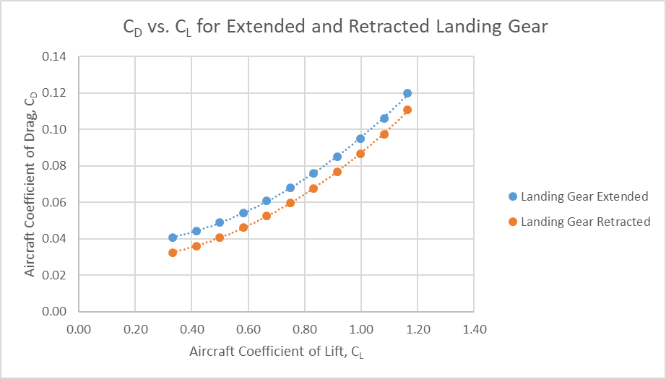

1. **Plot of CD vs. CL2 with extended landing gear and retracted landing gear**:

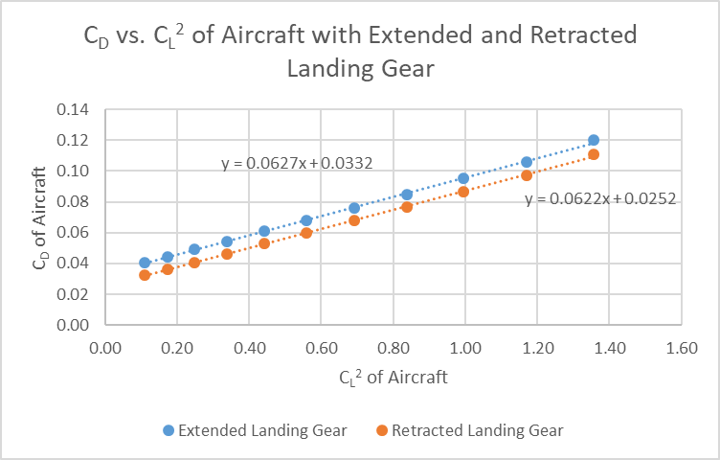

1. **Estimating CD,0 and e for cases with landing gear extended or retracted**:

Calculation to determine CD,0 and e when landing gear are extended:

CD,0 is the y-intercept on the CD vs. CL2 plot, which is 0.0332. The value of Oswald’s efficiency, e, is calculated using the equation $C_{D}=C_{D,0}+\frac{C_{L}^{2}}{π\left(AR\right)e}$, meaning that the slope of the CD vs. CL2 plot is equal to 1/(π(AR)(e)). Therefore, e = 1/((Slope of plot)π(AR)) = 1/((0.0627)* π*(6.2007)) = 0.8187

The procedure to find the value of CD,0 and e when the landing gear are retracted is the exact same except it makes use of the line corresponding to the retracted landing gear on the CD vs. CL2 plot rather than the line resulting when the landing gear are extended.

CD,0 = the y-intercept of this line = 0.0252

The slope of the line resulting from data taken with retracted landing gear is 0.0622, meaning that the value of e = 1/((0.0622)* π*(6.2007)) = 0.8253

1. **The final drag polar of the aircraft with the landing gear extended is**:

$C_{D}=C_{D,0}+\frac{C_{L}^{2}}{π\left(AR\right)e}=0.0332+\frac{C_{L}^{2}}{π(6.2007)(0.8187)}=0.0332+0.0627C_{L}^{2}$

Similarly, the final drag polar of the aircraft with the landing gear retracted is:

$$C_{D}=C_{D,0}+\frac{C_{L}^{2}}{π\left(AR\right)e}=0.0252+\frac{C_{L}^{2}}{π(6.2007)(0.8253)}=0.0252+0.0622C_{L}^{2}$$

1. **Figure of Aircraft CD vs. CL data points with respective Drag Polars for extended and retracted landing gear**:

